AP US GOVERNMENT AND POLITICS (AP GoPo)
COURSE SYLLABUS

Aaron Hughes
The AP US Government and Politics exam will be the morning of 5/10/2016
Room 221
729-5546
hughes@owosso.k12.mi.us
http://mrhughesohs.weebly.com/
@ohsapgov

Welcome!

Let me take this opportunity to thank you for agreeing to take this enormous challenge. This course provides you with the experience of a college level course prior to leaving high school. In addition to studying U.S. Government you will begin to develop the necessary skills to achieve success in college.

In order to be successful in this class, a great deal of reading will be required both from the text (Wilson) and outside readers (i.e. Lanahan, newspapers). Participation will be expected in in-class and out-of-class assignments, vocabulary assignments, current events assignments, on-line assignments, concept discussions, debates, etc. I strongly recommend that you keep all materials for this course in a three-ring binder or some other type of organizational system. You should either use flashcards or keep a simple notebook or special section in your binder for all of the vocabulary work we will have to do. Each chapter quiz will have a great deal to do with vocabulary.

Course Texts:
-Wilson, James Q., and John J. DiLulio Jr. 1998. American Government: Institutions and Policies. 7th ed. Boston: Houghton Mifflin.
-Serow, Ann G. and Everett C. Ladd (Eds) 2000. The Lanahan Readings in the American Polity. 2nd Edition. Baltimore: Lanahan. (NOTE: This text is noted below as “Lanahan.”)
-Daily access to mass print media (USA Today, MSNBC, Newsweek) (recommended). Note: many outstanding news sources are available online for free. See me if you need resources.

Course Goals:
- Prepare students for AP exam on 5/10/2016.
- Develop young active citizens who can vote, analyze and read the newspaper (the main section), Familiarize students with the rigor of a college level Poli-Sci course.
- Develop technical writing skills.
- Develop and critically examine information provided through other forms of media and society
- Develop understanding of multiple perspectives (Interest Group Politics and Social Policy).

Course Expectations:
- Reading assignments will be completed before discussion begins.
- Students will review and amend lecture notes.
- Students will develop technical writing skills versus traditional essay writing techniques.
- Students will be able to speak the language (vocabulary).
- Students will complete chapter guides for each chapter.
- Students will ALWAYS be prepared for ‘pop-quizzes’ over reading material.
- Students will be able to self-teach a chapter if needed and prepare self for in class quizzes.
- Students will have access to a major newspaper, e-media outlet and the internet.
- Students will be e-students, communicating with teacher and classmates as needed.
- Students will not submit late work. (Unless special circumstances)
- Students will submit work when it is due regardless of absence. (Unless special circumstances)

Class Activities:

- Vocabulary assignment for each chapter in Wilson (cards or list)
- Each vocab assignment will be saved for future review
- Online Notes
- Chapter study questions
- Other assignments
- Free response writing
  - Free-response writings will provide students with practice in analyzing and interpreting data and other information relevant to U.S. government and politics.
- Unit Tests consisting of multiple choice questions, vocabulary, and free response questions
- Chapter Quizzes – usually 20-30 questions
- Includes complete vocab review
- AP exam review
- Others as needed

The dates below are tentative to class activities and may vary. Use this schedule as a guide for pacing the textbook readings. All students are expected to complete the corresponding chapter readings in each unit by the date of the quiz. Additional Readings are to be completed by a date assigned from the instructor, depending on discussions.

Course Outline:

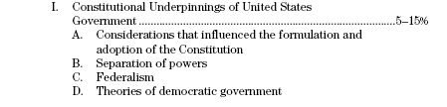
The study of modern politics in the United States requires students to examine the kind of government established by the Constitution, paying particular attention to federalism and the separation of powers. Understanding these developments involves both knowledge of the historical situation at the time of the Constitutional Convention and an awareness of the ideological and philosophical traditions on which the framers drew. Such understanding addresses specific concerns of the framers: e.g., Why did Madison fear factions? What were the reasons for the swift adoption of the Bill of Rights? Familiarity with the Supreme Court's interpretation of key provisions of the Constitution will aid student understanding of theoretical and practical features of federalism and the separation of powers. Students should be familiar with a variety of theoretical perspectives relating to the Constitution, such as democratic theory, theories of republican government, pluralism, and elitism.
Unit 1 test –10/1/2015

Week 1 - Ch. 1- The study of American Government
Quiz 9/14/2015
Additonal Reading(s): Lanahan, 9 - Richard Hofstadter, page 55

Week 2 Ch. 2- The Constitution
Quiz 9/18/2015
Additonal Reading(s): Lanahan, 10 The Federalist 10, page 61
16 The Federalist 51, page 107

Week 3 Ch. 3- Federalism
Quiz 9/28/2015
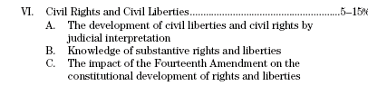
An understanding of United States politics includes the study of the development of individual rights and liberties and their impact on citizens. Basic to this study is an analysis of the workings of the Supreme Court and an understanding of its most significant decisions. Students should examine judicial interpretations of various civil rights and liberties such as freedom of speech, assembly, and expression; the rights of the accused; and the rights of minority groups and women. For example, students should understand the legal, social, and political evolution following the Supreme Court's decisions regarding racial segregation. Finally, it is important that students be able to assess the strengths and weaknesses of Supreme Court decisions as tools of social change.
Unit 2 Test 10/22/2015

Ch. 5- Civil Liberties
Quiz 10/9/2015

Ch. 6- Civil Rights
Quiz 10/16/2015

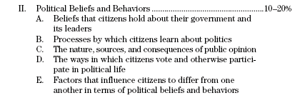
Individual citizens hold a variety of beliefs about their government, its leaders, and the U.S. political system in general; taken together, these beliefs form the foundation of U.S. political culture. It is important for students to understand how these beliefs are formed, how they evolve, and the processes by which they are transmitted. Students should know why U.S. citizens hold certain beliefs about politics, and how families, schools, and the media act to perpetuate or change these beliefs. Understanding the ways in which political culture affects and informs political participation is also critical. For example, students should know that individuals often engage in multiple forms of political participation, including voting, protest, and mass movements. Students should understand both why individuals engage in various forms of political participation and how that participation affects the political system.
Finally, it is essential that students understand what leads citizens to differ from one another in their political beliefs and behaviors, and the political consequences of these differences. To understand these differences, students should focus on the different views that people hold of the political process, the demographic features of the American population, and the belief and behavior systems held by specific ethnic, minority, and other groups.
Unit 3 test – 11/18/2015

Ch. 4- American Political Culture
Quiz 10/30/2015

Ch. 7- Public Opinion
Quiz 11/6/2015
Additonal Reading(s): Lanahan, 62, “Dirty Little Secrets” (Sabato & Simpson) 417

Ch. 8- Political Participation
Quiz 11/13/2015

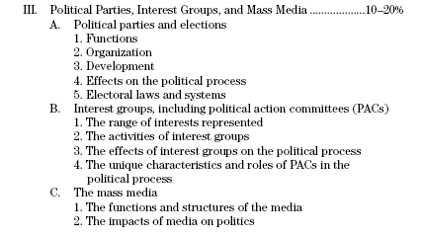
Students should understand the mechanisms that allow citizens to organize and communicate their interests and concerns. Among these are political parties, elections, political action committees (PACs), interest groups, and the mass media. Students should examine the historical evolution of the U.S. party system, the functions and structures of political parties, and the effects they have on the political process. Examination of issues of party reform and of campaign strategies and financing in the electronic age provides students with important perspectives. A study of elections, election laws, and election systems on the national and state levels will help students understand the nature of both party and individual voting behavior. Treatment of the development and the role of PACs in elections and the ideological and demographic differences between the two major parties, as well as third parties, form an important segment of this material.
Students must also consider the political roles played by a variety of lobbying and interest groups. Important features of this section of the course include an explanation for why some interests are represented by organized groups while others are not, and the consequences of these differences. Students study what interest groups do, how they do it, and how this affects both the political process and public policy. Why are certain segments of the population, such as farmers and the elderly, able to exert pressure on political institutions and actors in order to obtain favorable policies?
The media has become a major force in U.S. politics. Students are expected to understand the role of the media in the political system. In addition, the impact of the media on public opinion, voter perceptions, campaign strategies, electoral outcomes, agenda development, and the images of officials and candidates should be explored and understood by students. Understanding the often symbiotic, and frequently conflictual, relationship between candidates, elected officials, and the media is also important.

Unit 4 test – 1/11/2016

Ch. 9- Political Parties
Quiz 12/2/2015

Ch. 10- Elections and Campaigns
Quiz 12/8/2015
Additonal Reading(s): Lanahan, 63 “Going Negative” (Ansolabehere & Iyengar) 426

Ch. 11- Interest Groups
Quiz 12/16/2015

Ch. 12- The Media
Quiz 11/6/2016
Additonal Reading(s): Lanahan, 72 “Feeding Frenzy” (Sabato) 491

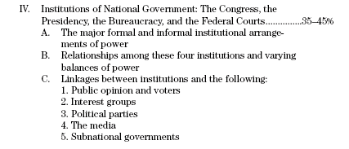
Students must become familiar with the organization and powers, both formal and informal, of the major political institutions in the United States- the Congress, the presidency, the bureaucracy, and the federal courts. The functions these institutions perform and do not perform, as well as the powers that they do and do not possess, are important. It is necessary for students to understand that power balances and relationships between these institutions may evolve gradually or change dramatically as a result of crises. Students are also expected to understand ties between the various branches of national government and political parties, interest groups, the media, and state and local governments. For example, a study of the conflicting interests and powers of the President and Congress may help explain recent and repeated struggles to adopt a national budget.

Unit 5 test – 3/4/2016

Ch. 13- Congress
Quiz 2/2/2016
Additonal Reading(s): Lanahan, 31, “The Congressional Experience” (Price) 193
60 Vote Senate
Lanahan, 29, “Pork: A Time-Honored Tradition Lives On”
(Starobin) 185
Lanahan, 30, “In Praise of Pork” (Ellwood & Patashnik)
188

Ch. 14- The Presidency
Quiz 2/10/2016
Additonal Reading(s): Lanahan, 35, “Paradoxes of the American Presidency”
(Cronin & Genovese) 224

Ch. 15- The Bureaucracy
Quiz 2/19/2016
Additonal Reading(s): Lanahan, 38, “A Government of Strangers” (Helco) 257

Ch. 16- The Judiciary
Quiz 2/29/2016
Additonal Reading(s): Lanahan, 44, “Storm Center” (O’Brien) 301

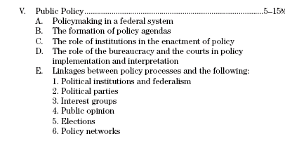

Public policy is the result of interactions and dynamics among actors, interests, institutions, and processes. The formation of policy agendas, the enactment of public policies by Congress and the President, and the implementation and interpretation of policies by the bureaucracy and the courts are all stages in the policy process with which students should be familiar. Students should also investigate policy networks, iron triangles, and other forms of policy sub governments in the domestic and foreign policy areas. The study of these will give students a clear understanding of the impact of federalism, interest groups, parties, and elections on policy processes and policy making in the federal context.

Unit 6 Test – 3/30/2016

Ch. 17-18- The Policy-Making Process, Economic Policy, and Social Welfare
Quiz 3/18/2016

Additonal Reading(s): Lanahan, 87, “The Other America” (Harrington) 613

Additonal Reading(s): Lanahan, 90, “Tyranny of Kindness” (Funiciello) 627

Ch. 19-20 – Foreign Policy and Military Policy
Quiz 3/25/2016

Review for AP Exam: 4/12/2016 – 5/9/2016

AP Exam Format 5/10/2016

Multiple Choice: 60 Questions, 45 Minutes

Free Response: 4 Mandatory Questions, 100 Minutes. (any order)
Students will have plenty of practice (every two weeks) in analyzing and interpreting data and other information relevant to U.S. government and politics.

Tips:
Answer easiest questions first
Write technically
Answer all parts of question exactly
Expect one question to involve a map, chart, graph, etc.

We will spend a large amount time preparing for the AP Exam.

Grading
Your grade for the course will be broken down using the following weights:
Unit Tests and Projects: 60%
Chapter Quizzes: 25%
Chapter Homework, Classroom Work and Activities, and Current Events: 15%

Grading Scale:
A+ 100% A 93% A- 90% B+ 87% B 83% B- 80% C+ 77%

C 73% C-70% D+ 67% D 63% D- 60% F 0-59%

Weighted Grades: Courses weighted AP carry weighted grades when computing GPAs.

GRADE | STANDARD GPA VALUE | X 1.333 | WEIGHTED GPA VALUE
A | 4.0 |  | 5.32
A- | 3.8 |  | 5.05
B+ | 3.5 |  | 4.65
B | 3.0 |  | 3.99
B- | 2.8 |  | 3.72
C+ | 2.5 |  | 3.32
C | 2.0 |  | 2.66
C- | 1.8 |  | 2.39
D+ | 1.5 |  | 1.99
D | 1.0 |  | 1.33
D- | .8 |  | 1.06

